1. History of SAP
SAP was founded in 1972 in Germany by five former IBM employees. It was created to provide real-time, integrated business software to help companies run their operations efficiently.
2.What is ERP
ERP stands for Enterprise Resource Planning and it is software that manages all major business activities of a company in one integrated system. It helps departments share data and work together in real time.
3.SAP Architecture
SAP follows a three-tier architecture that separates user interface, business logic, and data storage. This design improves performance, security, and scalability of the system.
*Presentation Layer
The presentation layer is the user interface of SAP where users interact with the system using SAP GUI or Fiori. It only displays data and sends user requests to the application layer.
*Application Layer
The application layer processes all business logic and executes user requests. It contains application servers that communicate with the database and manage system workload.
*Database Layer
The database layer stores all business data of SAP in tables. Users cannot access it directly and all data operations are handled through the application layer.
*SAP Evolution:
SAP R/1
SAP R/1 was the first version of SAP and followed a single-tier architecture. It was simple but not scalable and suitable only for small organizations.
SAP R/2
SAP R/2 used a two-tier architecture and ran on mainframe computers. It supported large enterprises but was expensive and lacked flexibility.
SAP R/3
SAP R/3 introduced a three-tier client-server architecture. It was flexible, scalable, and became the foundation for modern SAP systems.

4.Difference Between ECC and S/4HANA
SAP ECC
SAP ECC stands for Enterprise Core Component and is the older ERP system of SAP. It supports multiple databases and was widely used before S/4HANA.
SAP HANA
SAP HANA is a high-performance in-memory database that processes data in real time. It significantly improves system speed and reporting performance.
*SAP ECC is disk-based and slower, while SAP S/4HANA is in-memory and much faster. *S/4HANA also has a simplified data model and modern user interface.
| Feature | SAP ECC | SAP HANA / S/4HANA
| Type | Traditional ERP | Next-gen ERP
| Database | Oracle, DB2, SQL Server | HANA only (in-memory)
| Speed | Slower |Very fast
| Data storage | Disk-based | In-memory (RAM)
| Tables | Many redundant tables | Simplified tables
| Reporting | Separate tools needed | Real-time reporting
| User Interface | SAP GUI | Fiori (web-based)
| Code | Classic ABAP | Optimized ABAP for HANA
| Year | Older (2004) | New (2015)
SAP S/4HANA
SAP S/4HANA is SAP’s latest ERP system built on the HANA database. It enables real-time business processing with simplified architecture and faster performance.
5.SAP Landscape
SAP landscape is a set of SAP systems used by a company to develop, test, and run SAP safely. It ensures that changes do not affect live business operations.

*The set of SAP systems used by a company to develop, test, and run SAP safely.
Standard SAP Landscape (Most Common)
DEV (Development)
- Where developers work
- Write ABAP code
- Configure SAP
QAS / QA (Quality / Testing)
- Used for testing
- Checks if changes work correctly
- Used by testers & functional consultants
PRD (Production)
- Live system
- Real business data
- Used by actual users (finance, sales, HR)
Development System (DEV)
The DEV system is used to develop programs and configure SAP settings. It allows developers to make changes without affecting business users.
Quality System (QAS)
The QAS system is used to test all developments and configurations. It ensures changes work correctly before moving to production.
Production System (PRD)
The PRD system is the live system used by end users for daily business operations. It contains real business data and must be stable.
6.SAP ABAP
SAP ABAP is the programming language used to develop and customize SAP applications. It is used to create reports, forms, interfaces, and enhancements.
The programming language of SAP
ABAP stands for Advanced Business Application Programming.
Tools ABAP developers use
- SE38 / ABAP Editor – write programs
- SE11 – data dictionary (tables, views)
- SE80 – Object Navigator
- ADT (Eclipse) – modern ABAP development

7.SAP Modules
SAP modules are functional and technical components that manage different business areas such as finance, sales, materials, and human resources. Each module focuses on a specific business function.
*SAP Functional Modules
SAP FICO
Finance and Controlling – manages accounting, financial reporting, costs, and profitability.
SAP MM
Materials Management – handles procurement, inventory, and vendor management.
SAP SD
Sales and Distribution – manages sales orders, pricing, billing, and delivery.
SAP PP
Production Planning – plans and controls manufacturing and production processes.
SAP HCM / HR
Human Capital Management – manages employees, payroll, recruitment, and attendance.
SAP QM
Quality Management – ensures product quality through inspections and controls.
SAP PM
Plant Maintenance – manages equipment maintenance and repair activities.
* Technical SAP Modules
SAP ABAP
Programming language used to customize and develop SAP applications.
SAP BASIS
System administration – installation, configuration, performance, and security.

8.SAP Application Layer Components
The application layer contains components that handle request processing, load balancing, communication, and data locking. These components ensure smooth system operation.
Dialog (D) – user actions
Update (U) – database updates
Background (B) – long jobs
Spool (S) – printing
Enqueue (E) – locking data
Dispatcher
The dispatcher receives user requests and distributes them to available work processes. It controls request flow within the application server.
Work Processes
Work processes execute tasks requested by users or background jobs. Different types of work processes handle different system activities.
Dialog
Dialog work processes handle online user requests and execute transactions interactively. They respond directly to user actions.
Update
Update work processes save changes permanently in the database. They ensure data consistency after dialog processing.
Background
Background work processes execute long-running jobs without user interaction. They are mainly used for reports and batch processing.
Spool
Spool work processes manage printing and output requests. They handle communication between SAP and printers.
Enqueue
Enqueue work processes manage locks on SAP data. They prevent multiple users from changing the same data at the same time.

9.What is Database?
A database is an organized collection of data that is stored electronically in a computer system. It is designed to store, manage, retrieve, and update large amounts of information efficiently and securely.
In simple words, a database is where all business data is stored permanently.
*Why a Database is Needed
In an organization, huge amounts of data are generated every day such as customer details, sales orders, employee records, financial transactions, and inventory information. Storing this data in files or Excel sheets is not safe or efficient. A database allows this data to be stored in a structured manner so that it can be accessed quickly and accurately.
*Data in a database is stored in the form of tables.
Each table consists of:
- Rows – represent individual records
- Columns – represent fields or attributes

10.What is ERP software?
An ERP system is integrated software that manages all core business processes of an organization using a single, shared database.
An ERP system (Enterprise Resource Planning system) is an integrated software solution used by organizations to manage and automate their core business processes in a single system. It connects different departments such as finance, sales, inventory, human resources, and production by using a common database.

11.Features of an ERP System
1. Centralized Database
An ERP system uses a single, centralized database where all business data is stored. This ensures data consistency and avoids duplication across departments.
2. Integration of Business Processes
ERP integrates different business functions such as finance, sales, inventory, and HR into one system. Changes made in one department are automatically reflected in others.
3. Real-Time Data Processing
ERP systems process data in real time, allowing users to access updated information instantly. This helps in faster decision-making and reporting.
4. Automation of Processes
ERP automates routine business activities like order processing, billing, payroll, and inventory updates. This reduces manual errors and saves time.
5. Scalability
ERP systems can grow with the organization. New users, modules, and business processes can be added as the company expands.
6. Security and Access Control
ERP systems provide role-based access, ensuring that users can only access data relevant to their job role. This protects sensitive business information.
7. Reporting and Analytics
ERP systems generate reports and analytics that help management monitor performance, track costs, and plan future strategies.

Types of ERP Systems
1. On-Premise ERP
On-premise ERP is installed and maintained on the company’s own servers. The organization has full control over data and security, but it requires high initial investment and maintenance.
2. Cloud-Based ERP
Cloud ERP is hosted on the vendor’s servers and accessed through the internet. It has lower cost, easy scalability, and minimal maintenance, making it popular with modern businesses.
3. Hybrid ERP
Hybrid ERP is a combination of on-premise and cloud ERP. Some business processes run on local servers, while others run on the cloud for flexibility.
4. Open-Source ERP
Open-source ERP provides source code access, allowing companies to customize the system. It is cost-effective but requires strong technical expertise for maintenance.

5. Industry-Specific ERP
Industry-specific ERP systems are designed for particular industries such as manufacturing, healthcare, retail, or education. They include features tailored to specific business needs.

Role of an SAP ABAP Consultant
An SAP ABAP consultant is responsible for developing, customizing, and maintaining SAP applications using the ABAP programming language.

What is Centralized?
A centralized system is a system where all data, control, and decision-making are managed from one central location. In this approach, all departments or branches depend on a single central system or server.
What is Decentralized?
A decentralized system is a system where data and control are distributed across multiple locations or systems. Each department or branch can manage its own data and make decisions independently.
*SE11 :-
In SAP ABAP, SE11 is the transaction code used to access the ABAP Dictionary. It is the central repository for defining and managing all data structures used within the SAP system.
Think of it as the "Architect’s Studio" for your database—it's where you define the blueprints for how data is stored and organized before any actual data is entered.
Core Functions of SE11
The ABAP Dictionary allows you to manage several key objects:
- Database Tables: You define the table names, fields, and technical settings (like the Buffering and Data Browser/Table View Editing options you previously asked about).
- Data Elements: These provide the semantic definition for a field (e.g., the label that appears on a screen like "Employee ID").
- Domains: These define the technical characteristics of a field, such as the data type (Character, Numeric) and the allowed length.
- Structures: These are similar to tables but do not store data in the database; they are used as temporary data templates within ABAP programs.
- Views: These allow you to combine data from multiple tables into a single logical view for easier reporting.
- Search Helps: These define the "F4" value help (dropdowns) that users see when they need to select a value for a field.

Delivery Class → Who owns the data
Data Class → Where the data is storedss
*Delivery class:
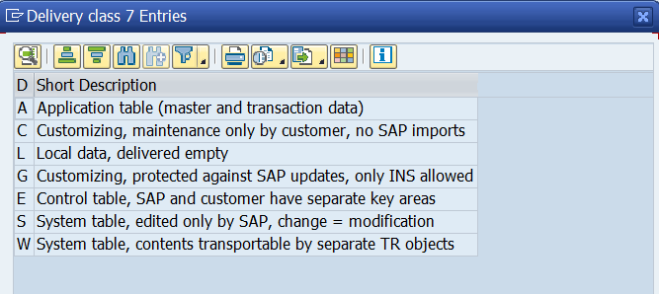
Used to transport the data between the systems.
Types :
ACLGESW
A-> Application Table:
These table Stores actual business data.
Use this for any table where data is created during daily business operations
Used For:
- Employee data
- Student records
- Orders
- Business data
C-> Customizing table:
Customer configuration data. (e.g., defining tax codes)
Data in these tables is usually maintained in Development and transported to Production.
L->Local Data:
Delivered empty by SAP.
Used for temporary data or "buffer" tables. These are delivered empty by SAP and are meant to hold local, transient information that doesn't need to be moved between systems.
G->Customizing (Protected):
Same as C but protected from SAP changes.
Only Insert (INS) allowed, not overwrite. Used in sensitive configuration tables.
E->Control Table:
Used when both SAP and the Customer need to put data in the same table. They have separate "namespaces" or key areas so they don't clash during an upgrade.

S->System Table:
Maintained only by SAP.
Only SAP should change these. If a customer changes them, it is considered a "modification" and can break the system during an upgrade.
W->System Table with Transportable Content:
System tables whose data is transported via its own specific transport objects.

*Data Class:
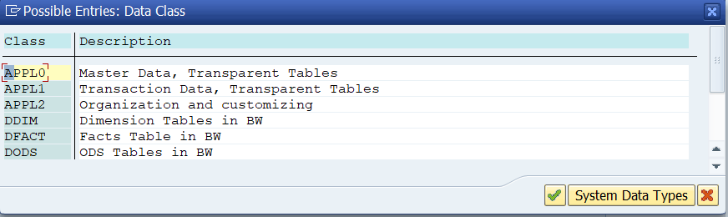
where the table should be physically stored in the database and what type of data it contains.
SAP uses Data Class to:
- Organize tables inside the database
- Improve performance
- Manage storage efficiently
- Separate master data from transaction data
Standard SAP Data Classes:
APPL0 (Master Data): (Data that does NOT change frequently)
Used for data that is rarely changed, such as customer names,addresses, or material descriptions.
APPL1 (Transaction Data): (Data that changes very often.)
Used for data that is frequently updated or created, such as sales orders, invoices, or financial postings.
APPL2 (Organization and Customizing): (Company structure and configuration data.)
Used for configuration data defined when the system is first set up, such as country codes or tax categories.

DDIM, DFACT, DODS:
These are specialized classes specifically for SAP Business Warehouse (BW) to handle dimension tables, fact tables, and Operational Data Store (ODS) objects.

*what is buffering?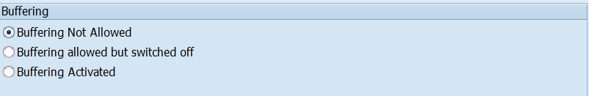
Buffering:
Storing frequently used table data in the application server memory
(local memory)instead of fetching it from the database every time.
Types of Buffering:
1.Single Record Buffering:
Only one record is buffered at a time.
Large tables where only a few records are frequently accessed using SELECT SINGLE.
2.Generic Buffering:
buffers groups of records based on part of the key.
Tables where users often work with a specific group of related records (e.g., all entries for one language or company code).
3. Full Buffering:
Entire table is loaded into memory.
The entire table is loaded into memory as soon as a single record is accessed.

* DDIC:
DDIC stands for Data Dictionary.
It is the central place in SAP where all database objects are defined and managed.
*It is a central repository used to create, manage, and maintain all data definitions used within an SAP system.
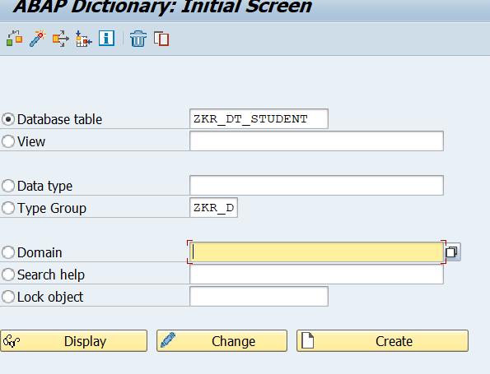

*Data Browser/Table View Editing:
To control who can view and maintain table data and prevent unauthorized changes.
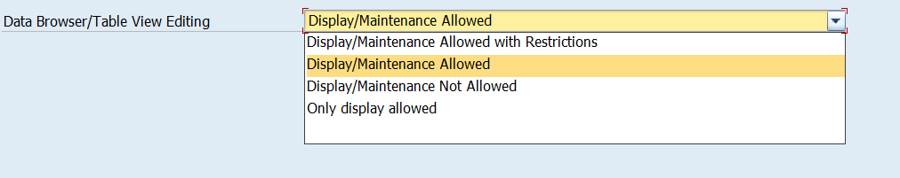
Display/Maintenance Allowed:
Users can view the data AND add/delete/change records directly in the table.
Display/Maintenance Allowed with Restrictions:
Users can edit the data, but there may be extra security checks or specific conditions required.
Display/Maintenance Not Allowed:
The data is "locked." No one can use standard tools to see or change it. It can only be accessed through a specific program.
Only Display Allowed:
Users can look at the data in the table, but the "New Entries" or "Delete" buttons will be disabled.

